Parent and Caregiver Application
New Jersey’s Family Engagement Hub Advisory Committee

Deadline for Submission: Ongoing
We are seeking a diverse group of parents and caregivers of children birth to Grade 12 from all counties of New Jersey to fill seats on our 2024 Advisory Committee. Applications are limited to parents and caregivers who are not professional educators or administrators. We are looking for families that have children currently enrolled in public schools in New Jersey.
Why should I invest my time?
You are invited to apply to be a part of this wonderful opportunity to share your ideas about how New Jersey families and schools can work together to support the education of all children.
Committee Purpose:
The purpose of the New Jersey Family Engagement Advisory Committee is to provide strategic advice and support for the activities of the New Jersey Family Engagement Hub. More specifically, the Advisory Committee is a group of family and organizational representatives who are responsible for helping the Hub develop and share resources for families and educational professionals.
Members:
There are approximately 30 members. The majority of members are family representatives (parents/caregivers). The Committee also includes school, organizational, and New Jersey Department of Education representatives.
Committee Member Expectations:
- Participate in the Committee for minimum of 1 year (April 15, 2024 - September 30, 2025)
- Attend four In-person and/or Virtual Zoom meetings from 9:00 am-12:00 pm (subject to change).
- Attend an annual retreat (date and time to be determined).
2024 Meeting Dates
April 29, June 24, September 30, and December 2

Compensation:
- Parent and Caregiver members are compensated with a stipend of $70 for each meeting in full attendance.
We are looking for an Advisory Committee (AC) that brings diverse experiences and perspectives to the table. As a result, you may be asked to provide demographic information that will assist us in ensuring the selected AC members represent the diversity that exists within our student population in the state of New Jersey. Please make sure you fill out all pages of the application before submitting. Submission instructions are on the last page.

Application
First Name: _______________________________
Last Name: ___________________________
Address: ______________________________________________________________________
City: _____________________ Zip Code: _________ County: ______________
Phone Number: (____) _________________
Email Address: ____________________________
What is the best way to contact you? By Phone ______ By Email ______
Please tell us how you heard about this opportunity: __________________________________________________________________________
Please tell us about your child or children below:
Age/s: __________________________________________________________________
Grade Level/s: ____________________________________________________________
Your Relationship to Child or Children: ________________________________________
(e.g., Grandmother, Father, Mother, Uncle, Foster parent, etc.)
Public School/s your child or children attend (School Name, City):
____________________________________________________________________________

Please select the race and ethnicity that you use to identify yourself:
_____American Indian or Alaskan Native
_____Asian or Pacific Islander
_____Black, Non-Hispanic/Latino
_____Black, Hispanic/Latino
_____White, Hispanic/Latino
_____White, Non-Hispanic/Latino
_____Multiracial
_____Other

Do you have access to internet and a device to participate in virtual meetings?
_______ Yes _______ No

If you require an accommodation such as live captioning or interpretation to participate in the Committee, please describe your needs in the space below.
____________________________________________________________________________
Directions: Please type/write responses after each question below.
- We realize that every family does not look the same or have the same history. There are single parents raising children, grandparents raising grandchildren, foster families, families who immigrated recently to New Jersey, etc. Briefly tell us a little about yourself, your family, and the community where you live (rural, urban, etc.)

- New Jersey’s Education Landscape has many diverse learners like students with disabilities, English learners, economically disadvantaged, gifted, children of migrant workers, homeless, etc. What experience or perspective can you bring as member of this Committee that could help shape the needs of these diverse learners?

- Why are you interested in being on this Committee?

- What questions do you have about this opportunity?

Submission Instructions

Please submit your completed application via email or US postal service.
Email: lmakleridley@spanadvocacy.org using subject line “Application for Advisory Committee”
Mailing Address: New Jersey Family Engagement Hub
Attention: Dr. Lanisha Makle-Ridley, Co-Project Director
c/o SPAN Parent Advocacy Network
570 Broad Street, Suite 702
Newark, New Jersey 07102

Thank you for your interest in being on New Jersey’s Statewide Family Engagement Hub Advisory Committee. We appreciate the time you are taking to apply for this opportunity. We plan to notify applicants of our decision via email or phone. If you have any questions, please email us at lmakleridley@spanadvocacy.org. Visit our website to learn more about the Hub and resources available for families and schools at www.njfehub.org.

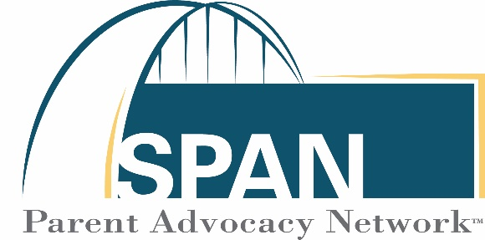
The New Jersey Statewide Family Engagement Hub is part of SPAN Parent Advocacy Network. SPAN’s mission is to empower and support families and inform and involve professionals interested in the healthy development and education of children and youth. SPAN’s motto is Empowered Parents: Educated, Engaged, Effective!

